***The Wizard Book Shop***

***Documentation.***

**Page**

**Table of content**

Introduction…………………………………………………………………………………1

Project Description…………………………………………………………………………2

Diagrams…………………………………………………………………………………… 2

**Introduction**

E-commerce (electronic commerce or EC) is the buying and selling of goods and services, or the transmitting of funds or data, over an electronic network, primarily the internet. These business transactions occur either as business-to-business, business-to consumer, consumer-to-consumer or consumer-to-business.

E-commerce shops have become part of our daily lives. Technological advancement has made it possible for people to sit in the convenience of their homes and still shop online without going to a physical shop.

This project is mainly divided into one main category: The Customers/Users.

**Project Description**

* Any member can register and view available products
* Only registered users can cash out the products
* There are 2 roles available
  + Visitor
  + Customer
* Visitors can view, search, and compare product/s that are available
* Users can view and purchase the product/s.

**User Story**

* As a Shopper I want to view a list of products so I can select some to purchase
* As a Shopper I want to review my cart so I can make adjustments prior to checkout
* As a Shopper I want to check out so I can get my products shipped to me
* As a Shopper I want to review my orders so I can see what I’ve purchased in the past

**Web Pages Details**

* Login
* Register
* View Products
* Cart Page
* Checkout

***Class Diagram***

A class diagram is a UML diagram type that describes a system by visualizing the different types of objects within a system and the kinds of static relationships that exist among them. It also illustrates the operations and attributes of the classes

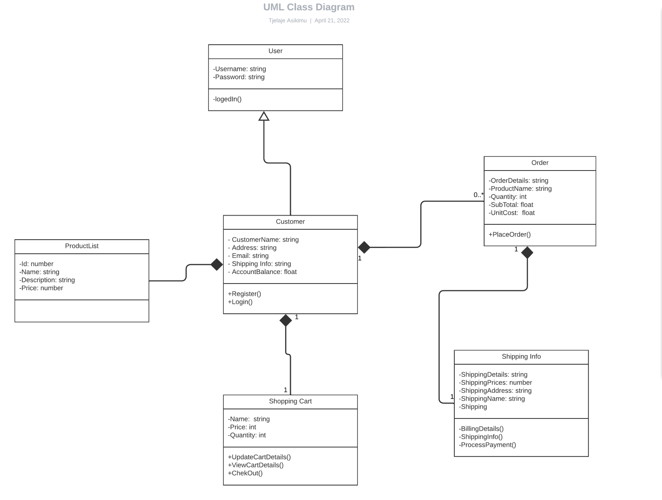

***Use Case Diagram***

These diagrams identify the interactions between the system and its actors.

It does not show the detail of the use cases: It only summarizes some of the relationships between use cases, actors, and systems

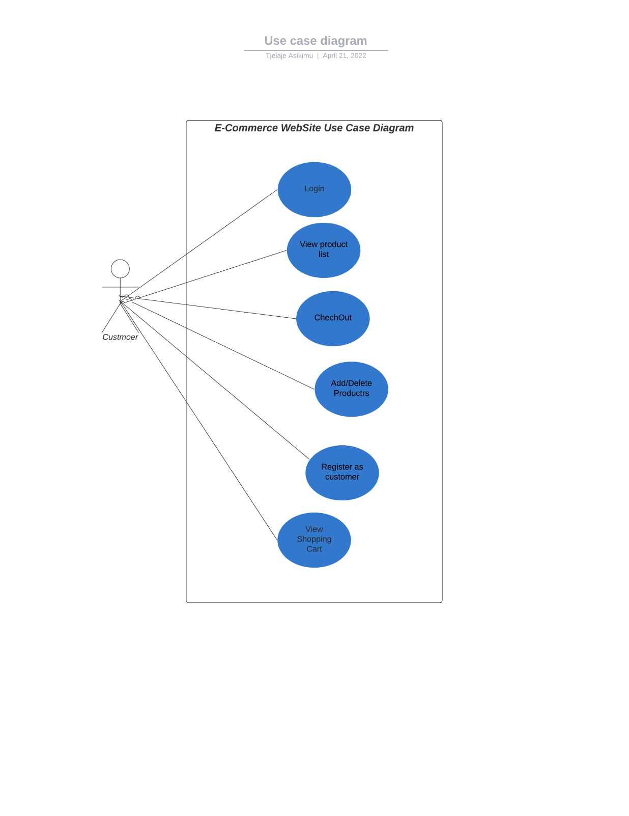

***Entity Relationship Diagram***

ER model is a design or blueprint of a database that can later be implemented as a database. It is also a type of flowchart that illustrates how “entities” such as people, objects or concepts relate to each other within a system.

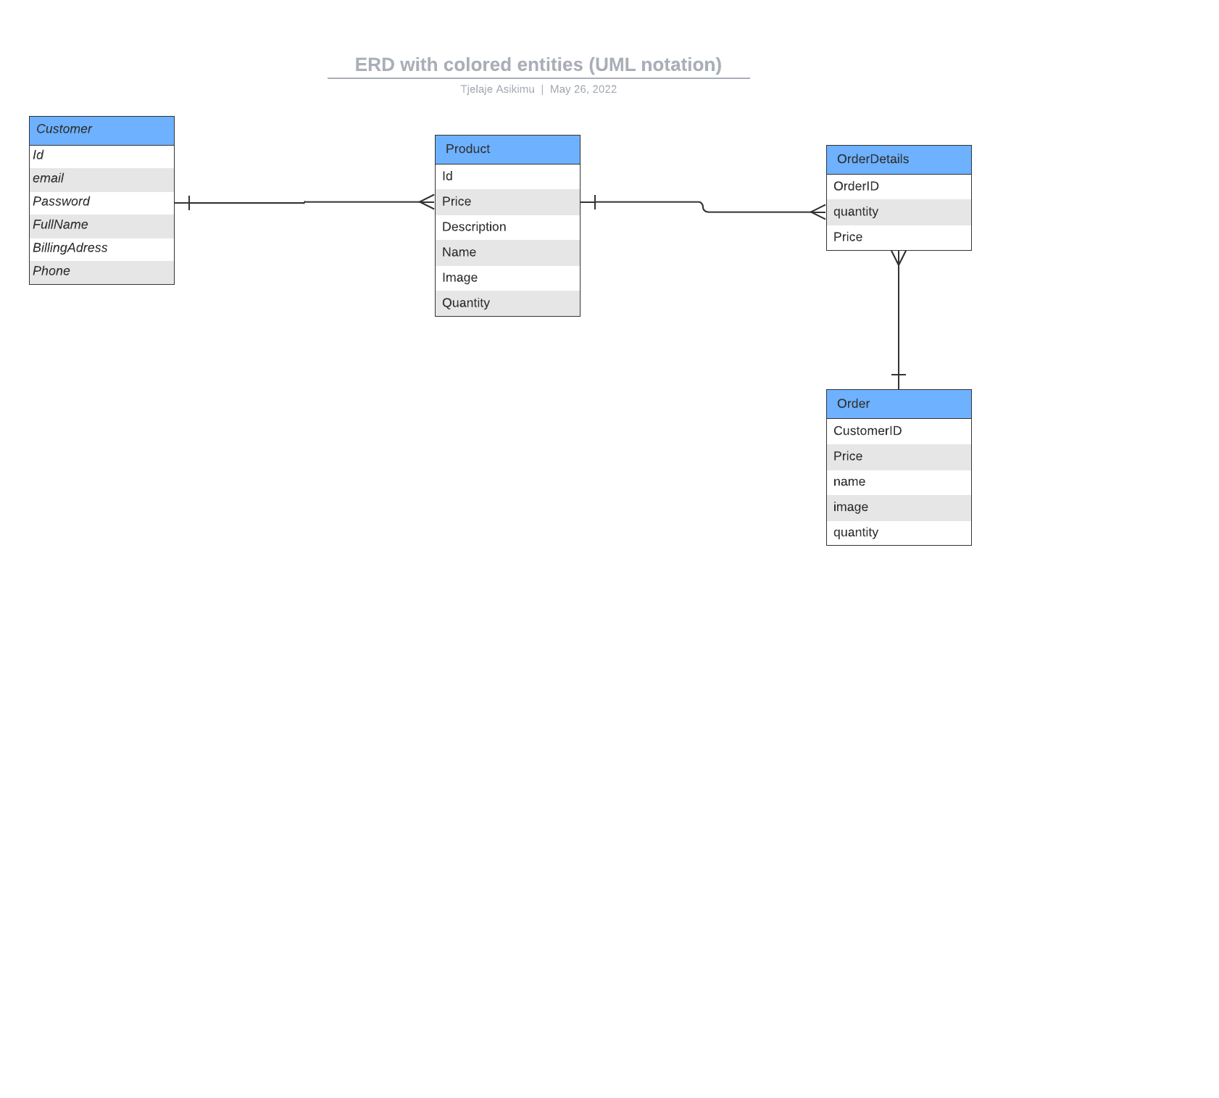

***Sequence Diagram***

Shows how the object/classes in the diagram interacts with each other.

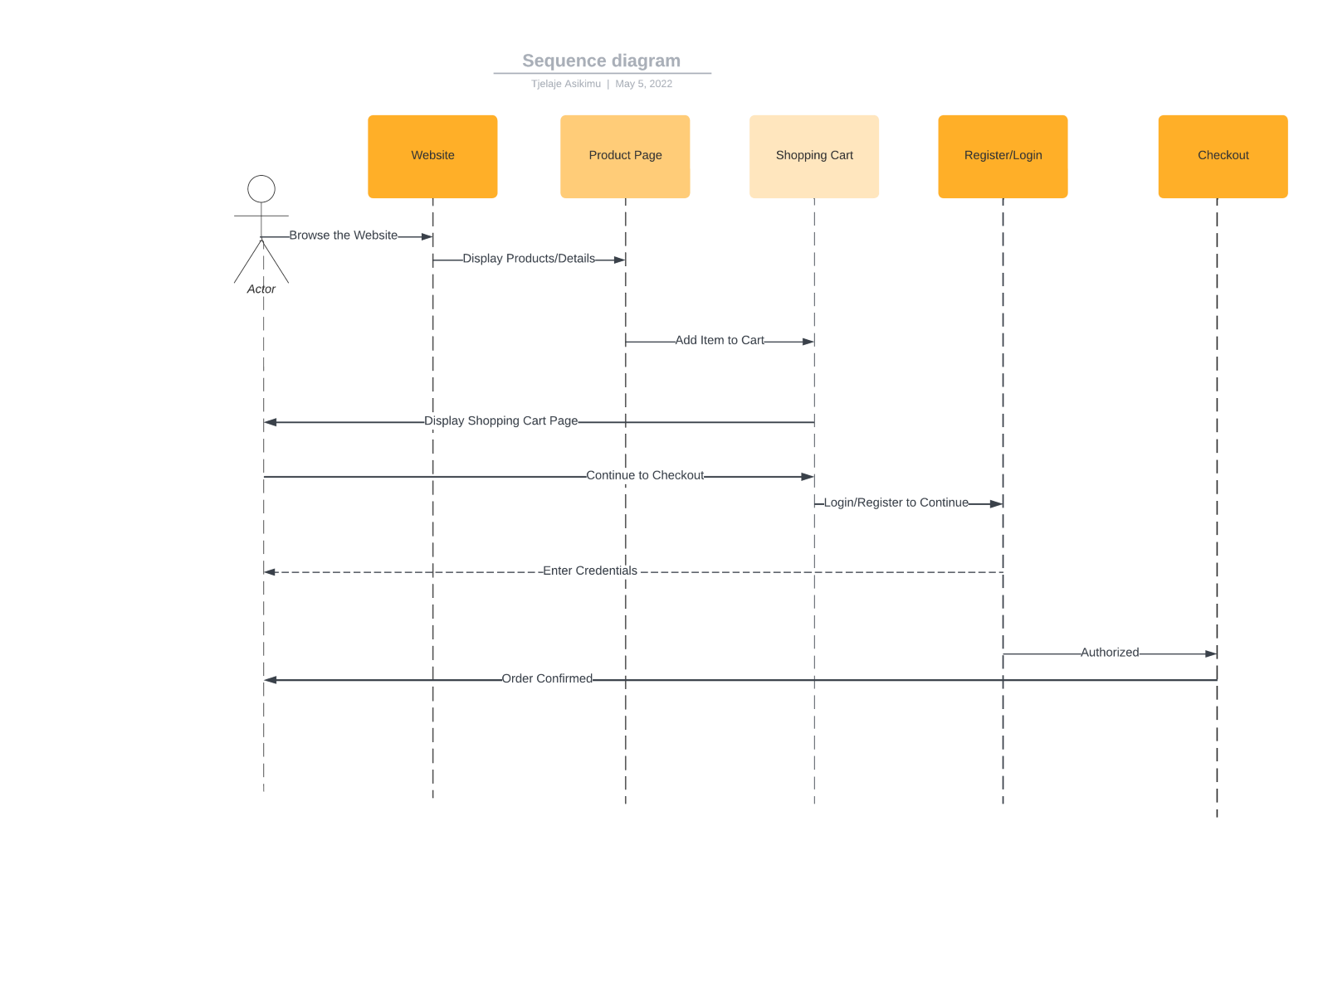

***Architecture Diagram***

A visual representation that maps out the physical implementation for components of a software system

***Data Flow Diagram***

A data flow diagram (DFD) maps out the flow of information for any process or system.

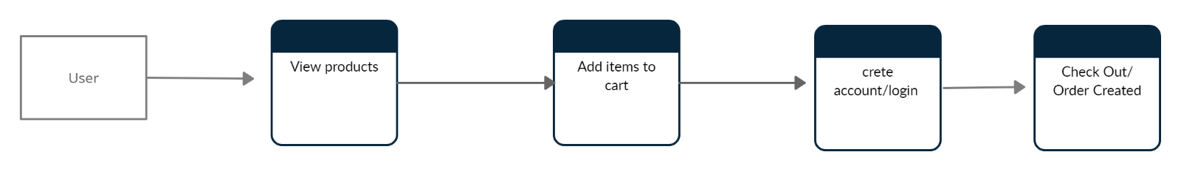

***UI Diagram***

The User Interface (UI) diagram is where you build out the visual structure of your application.

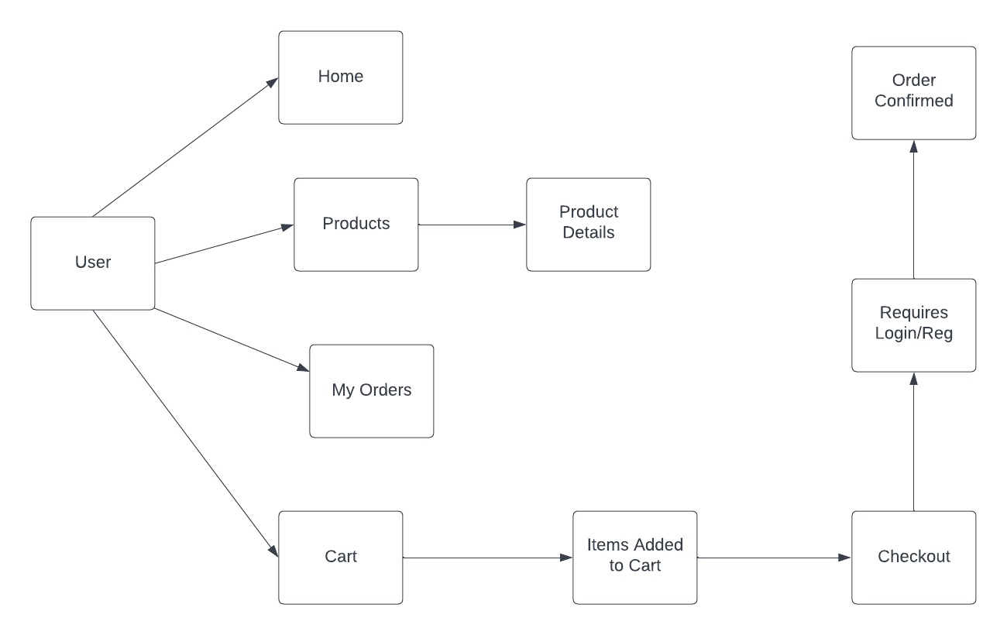

**Conclusion**

The electronic shop was developed using PHP, MySQL, HTML5 and CSS3 technology. Any consumer can browse products, add, replace or delete a product from the cart. The consumer can log in, with his information such as his username and password. If the login does not go through, the user can re-register. After login, the user can see the product in the cart and proceed onwards. The product can be paid to the given bank details.